1. Start Client app.

Open “NeuralNetStudioExcel\NeuralNetStudioExcelAddin\ClientApp” in VS code

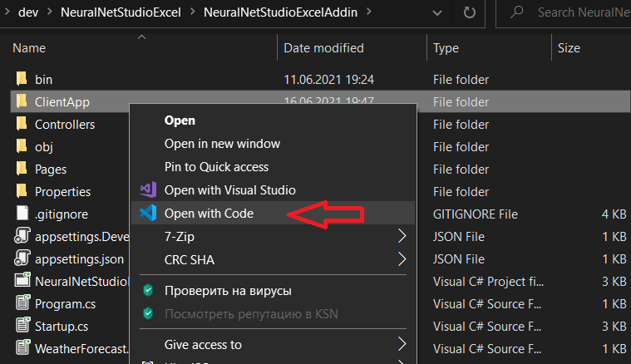

Go to Task Explorer and Start “start task”

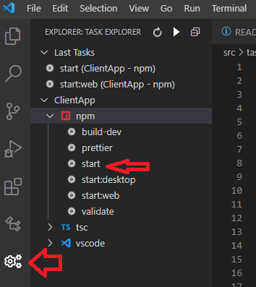

Or open Terminal and run commands:

Cd “c:\ … \NeuralNetStudioExcel\NeuralNetStudioExcelAddin\ClientApp”

npm run start

This will start NodeJS local server and open client app in Excel

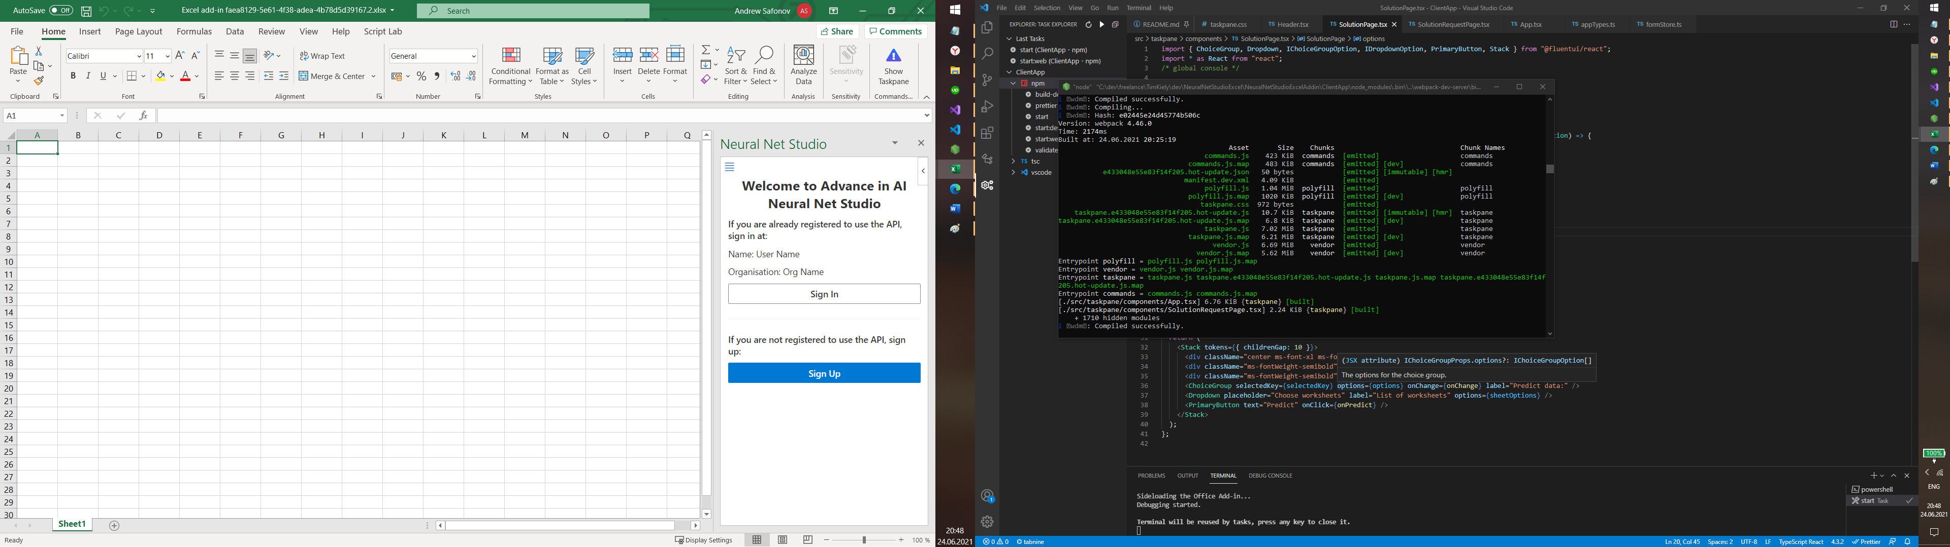

It use manifest file from ClientApp folder. (https://localhost:3000 /)

1. Start Server side project

Go To Visual Studio solution and start Debug

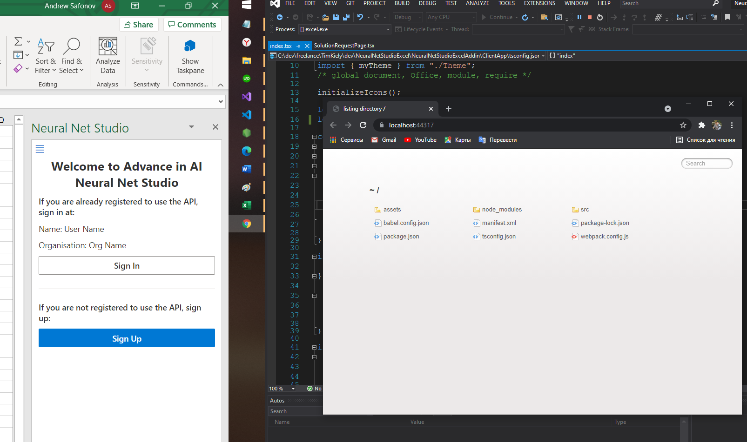

This will Open Excel with server app connected to Node local server.

Now you can Debug server app and edit client app with hot reload support.

It use manifest file from Visual Studio project. (https://localhost:44317/)